***Train Simulation***

Use Case Specification Document

**Case Id 1**

**Setup Initial State**

Version No. 2.0.0

**Project Document Revision History**

|  |  |  |  |
| --- | --- | --- | --- |
| **VersionNumber** | **Date** | **Revision Author** | **Description of Revision** |
| 1.0.0 | 3/14/2019 | Zaid Alsafi | 1.) Introduction  2.) Use Case Information  3.) Trigger  4.) Preconditions  5.) Postconditions  6.) Use Case Swimlane (Activity) Diagram  7.) Main/Basic Flow(s) of Events (Happy Path)  8.) Alternate/Exception Flow of Events  9.) Assumptions/Business Rules including Non-Functional Requirements |
| 2.1.0 | 4/18/2019 | Zaid Alsafi | Correcting any file assumptions and any grammar errors. |

**Table of Contents**

**1. Introduction** **4**

**2. Use Case Information** **4**

2.1 Actors 4

2.2 Use Case Interaction 4

**3. Trigger** **5**

**4. Pre-condition(s)** **5**

**5. Post-condition(s)** **5**

**6. Use Case Swimlane (Activity) Diagram** **6**

**7. Main/Basic Flow(s) of Events (Happy Path)** **7**

**8. Alternate/Exception Flow of Events** **8**

**9. Assumptions/Business Rules including Non-Functional Requirements** **8**

# 

# **1. Introduction**

User will be ~~able to~~ entering files of information for the simulation system to have an initial state for the simulation to run. Once all initial files are read the simulation will accept or decline any files that are not in the right format~~ion or with the correct data~~. When all files are accepted the simulation will have an initial state for it to be able to run the simulation.

# **2. Use Case Information**

## 2.1 Actors

|  |  |  |
| --- | --- | --- |
| **Actor Name** | **Role** | **Description** |
| User | Main Actor | This is a human that starts and stops the simulation. The actor can select files that would be read and processed and create breakpoints to pause the simulation to create a initial state.  ~~Start simulation to create new day. Weather is decided by user. View files~~ |
| Simulation system | Main Actor | ~~This is a system that Run files, display activities, and show visual representation of simulation graph~~ Runs the simulation using the data ~~about railroad and schedules~~ from the files given by the user. |

## 2.2 Use Case Interaction

A list of successor use cases are as follows:

Use Case 2 - Add/Remove Trains: After the setup of the initial state is successfully processed the user is able to add of remove trains after the end of day.

Use Case 3 - Edit Railway: After the setup of the initial state is successfully processed the user is able to edit the the railway by adding or removing tracks, station and hubs.

Use Case 4 - Adjust Weather: After the setup of the initial state is successfully processed the user is able to adjust the type of the weather and the severity of it.

Use Case 5 - Update Graph: After the setup of the initial state is successfully processed and successfully ran the graph will be updated.

Use Case 6 - Run Simulation:: After the setup of the initial state is successfully processed the simulation will be allowed to run.

Use Case 7 - Track Statistics: : After the setup of the initial state is successfully processed and simulation the is running it will keep track of the statistics.

Use Case 8 - Recommended Changes: After the setup of the initial state is successfully processed and simulation is running all recommended changes will be inputted in a file.

Use Case 9 - View Statics: After the setup initial state and the simulation ran the user is able to view all of the information from the initial states

Use Case 10 - RollBack Simulation History: After the setup initial state is successfully processed and the simulation ran the user is able to view previous initial states

# **3. Trigger**

The use case is triggered when the user enters all initial files and information for the simulation to ~~able to~~ be executed. This use case is triggered before the simulation is able to be runned.

# **4. Pre-condition(s)**

**~~4.1~~**~~. To setup the initial state, the user must have the files named correctly.~~

**4.2:** The files must be in the correct format and information.

**4.3:** The files must be input before the simulation will run.

# **5. Post-condition(s)**

**5.1:** After user imports data and the initial state is created, the user is able to run the simulation

**5.2:**  An error message will be displayed in the event of invalid files.

**5.3:** An error message will be displayed in the event of the File format is invalid.

# **6. Use Case Swimlane (Activity) Diagram**

~~OLD~~

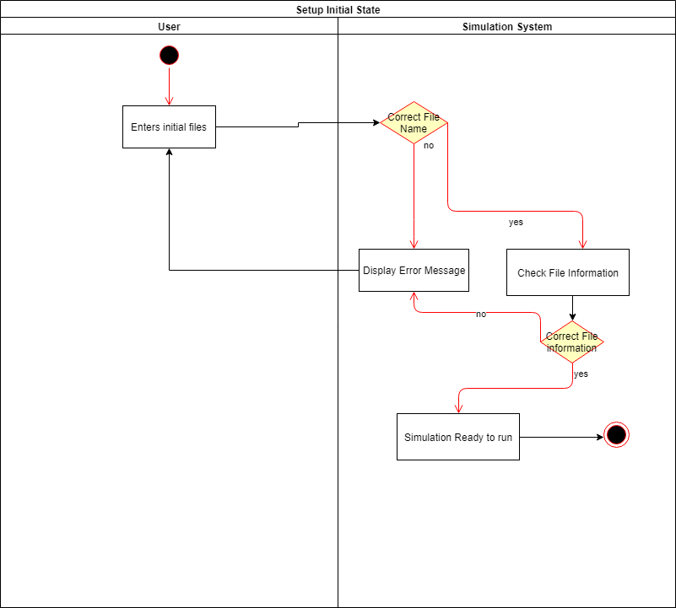

New

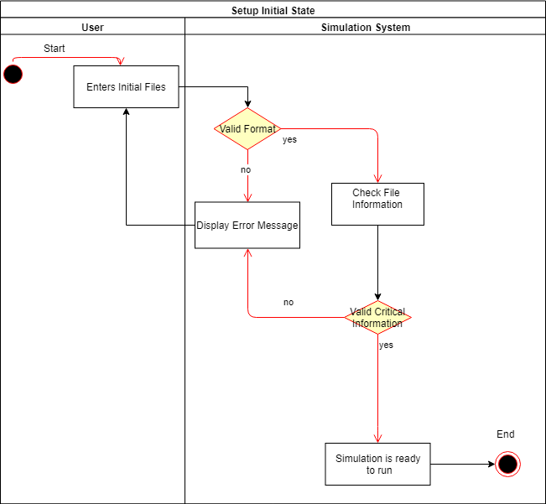

# **7. Main/Basic Flow(s) of Events (Happy Path)**

**7.1:** The simulation will open and ask the user for the files to setup an initial state

**7.2:** The user will enter the correct files with the ~~correct names,~~ format, and critical information

**7.3:** The program will setup the initial state and run the simulation.

# **8. Alternate/Exception Flow of Events**

**8.1:** If the user gives no files and tries to run the simulation the simulation will send an error message to the user and will ask to input missing files.

**8.2:** If the user does not give ~~enough~~  correct critical information in the files the program will send an error message and will ask the user for another file.

**~~8.3:~~** ~~If the user inputs a file but does not have the correct file name the system will send an error message and asks for the file with the correct name.~~

**8.4:** If the user inputs a file that does not have the correct format of information the system will send an error message to the user of the incorrect format of the file.

# **9. Assumptions/Business Rules including Non-Functional Requirements**